**PROPERTY ANALYSIS BI DEVELOPER- STANDARD SPRINT PART-2**

**DESIGN DATAWAREHOUSE & BUILD SSIS PACKAGE**

**Task 7: Using Suburb and City Dataset, design a Dim table - DimGeography with State / City / District / Postcode / Suburb / Lon / Lat**

**Control Flow:**

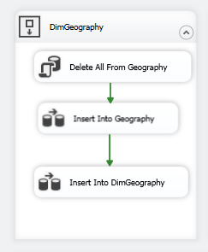

**Data Flow:**

**SAMPLE OUTPUT**

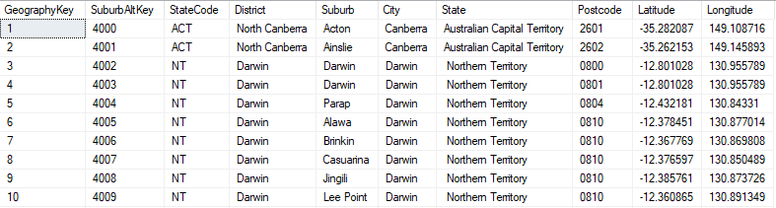

**Task 8: DimTransport: Load public transport data to StgTransport table**

**Control Flow:**

**Data Flow:**

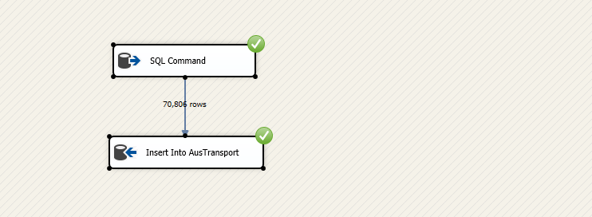

**SAMPLE OUTPUT:**

**Task 9: Add DimState with DWStateKey, StateCode and StateName**

**Control Flow:**

**Data Flow:**

**SAMPLE OUTPUT:**

**Task 10: Design DimAuLocalSchool tables for Aus local school**

**Control Flow:**

**Data Flow:**

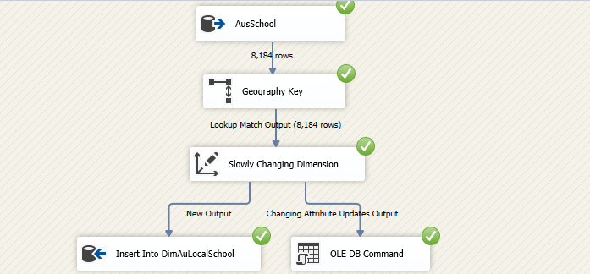

**SAMPLE OUTPUT:**

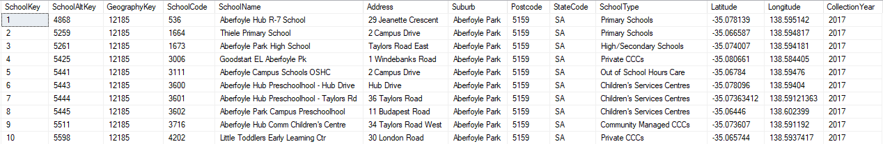

**Task 11: Design FactCrimeByYear**

**Control Flow:**

**Data Flow:**

**SAMPLE OUTPUT :**

**Task 12: Design FactSuburbRentalMedian**

**Control Flow:**

**Data Flow:**

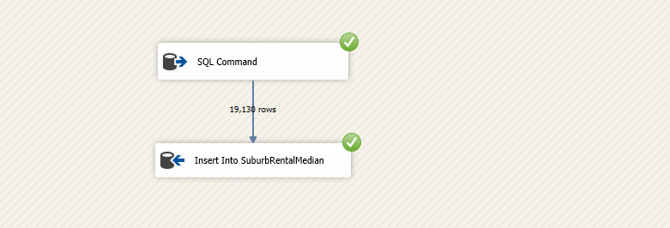

**SAMPLE OUTPUT:**

**Task 13: Design Fact table – FactMedianPropertyValueByYear**

**Control Flow:**

**Data Flow:**

**SAMPLE OUTPUT:**

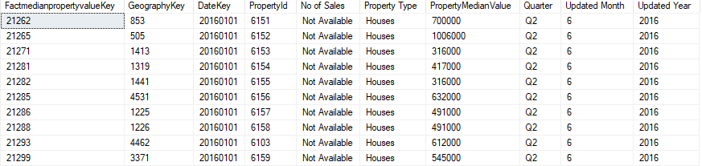

**Task 14: Design Fact table FactSuburbPopulation**

**Control Flow:**

**Data Flow:**

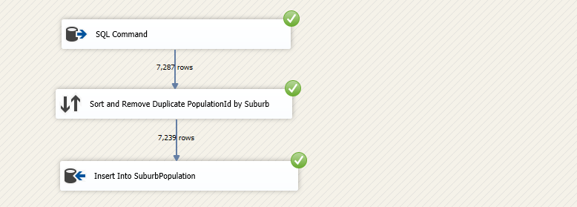

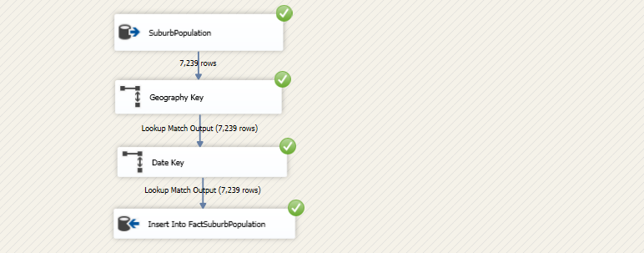

**SAMPLE OUTPUT:**

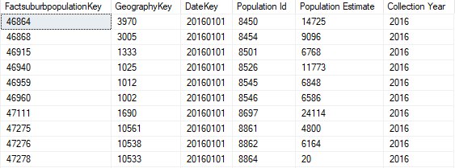

**FULL ETL CONTROL FLOW SCREENSHOT**

